|  |  |
| --- | --- |
| Team ID | PNT2022TMID30065 |
| Project Name | Skill/Job Recommended Application |

Steps

Create a kubernetes cluster

* Sign in to your IBM Cloud Dashboard
* Open IBM Kubernetes Service

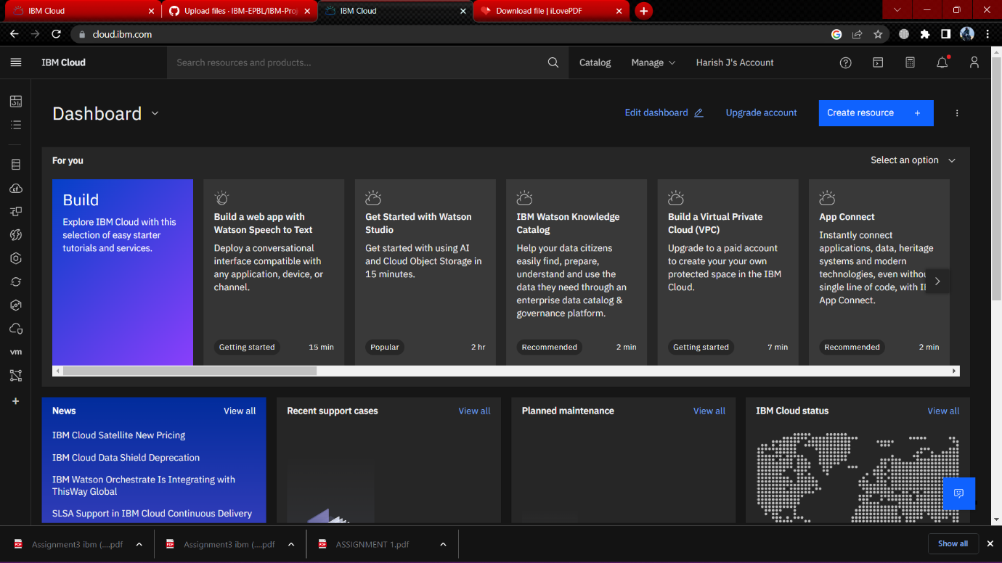

* Click **Create Cluster**

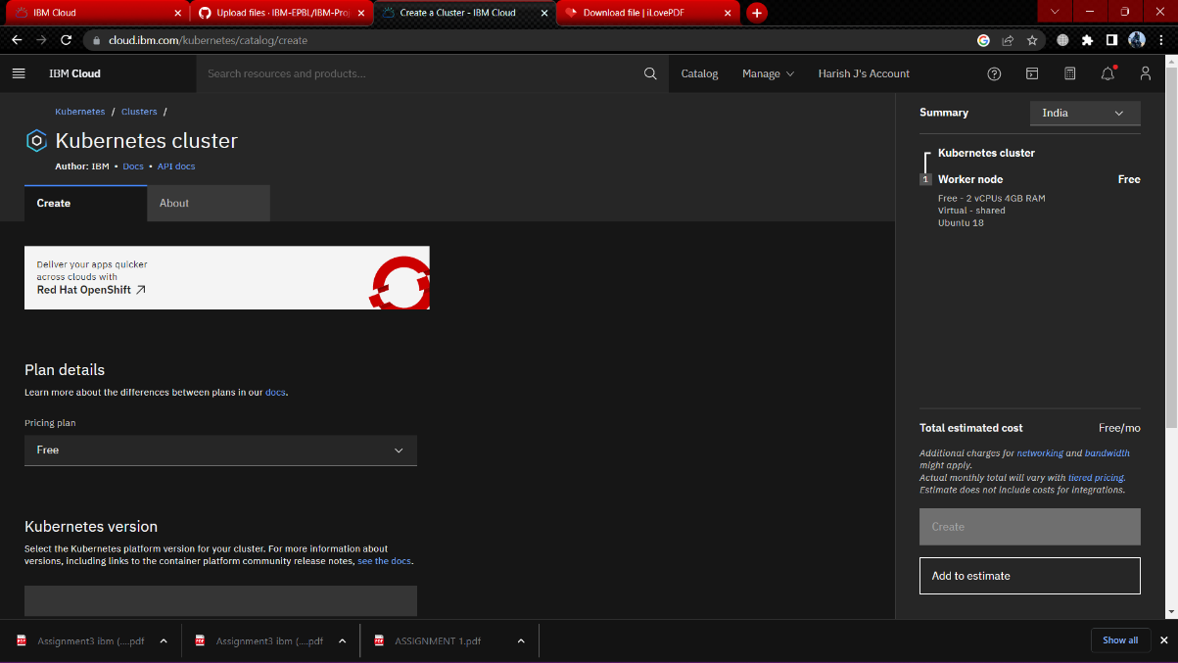

* Select **Region** where youo want to deploy the cluste ,type in a **name** for your cluster then click **Create Cluster.**
* Select the appropriate cluster type depending on your account.
* IT takes some time for cluster to get ready .

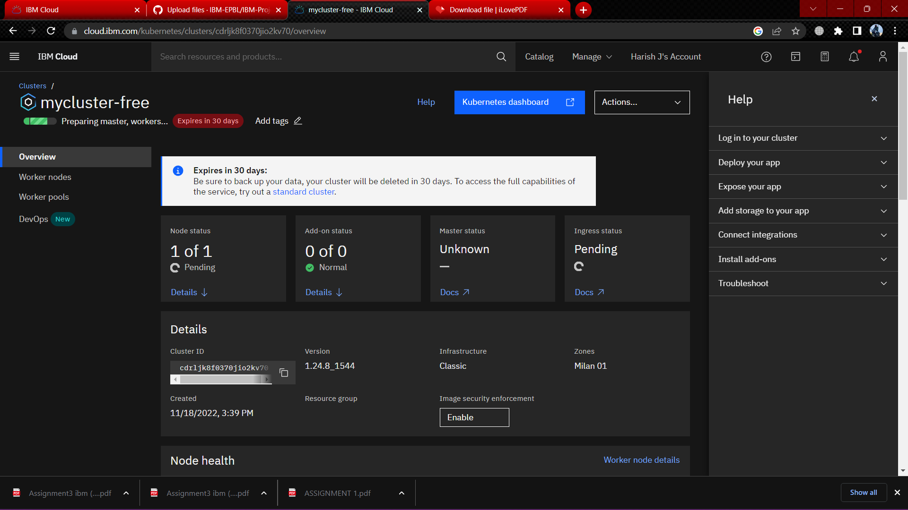

* Once the cluster is ready,click on your clusters name and you will be redirected to a new page with information about your cluster and worker node.

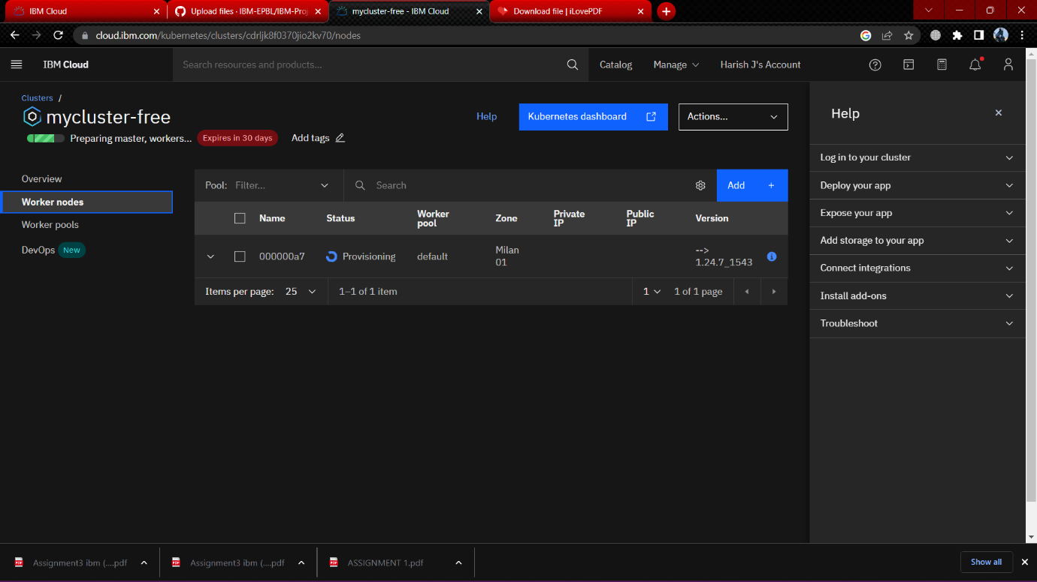

* Click on the Worker Nodes tab to note the clusters Public IP.